
School of Computer Science and Information Systems
Winter Semester 2025-2026
Agile Development Process and Devops Lab

Course faculty- SWETA BHATTACHARYA
Course Code – ISWE406P
Slot- C1+TC1

TOPIC : Jenkins Basics
Name: DHINESH.S
Reg no: 23MIS0396

LAB 1 – Jenkins Basics
Aim
To understand Jenkins and run a basic Freestyle job successfully.
Description
Jenkins is an open-source automation tool used to implement Continuous Integration and Continuous Deployment (CI/CD). It automates building, testing, and deploying applications.
Procedure
- Jenkins was installed on the system.
- Jenkins dashboard was accessed through a web browser.
- A Freestyle job named Hello-Jenkins was created.
- A simple Windows batch command echo Hello Jenkins was added.
- The job was executed manually.
- Console output and build history were verified.
Output
The job executed successfully and printed Hello Jenkins in the console.
Result
Jenkins was successfully installed and a basic job was executed.
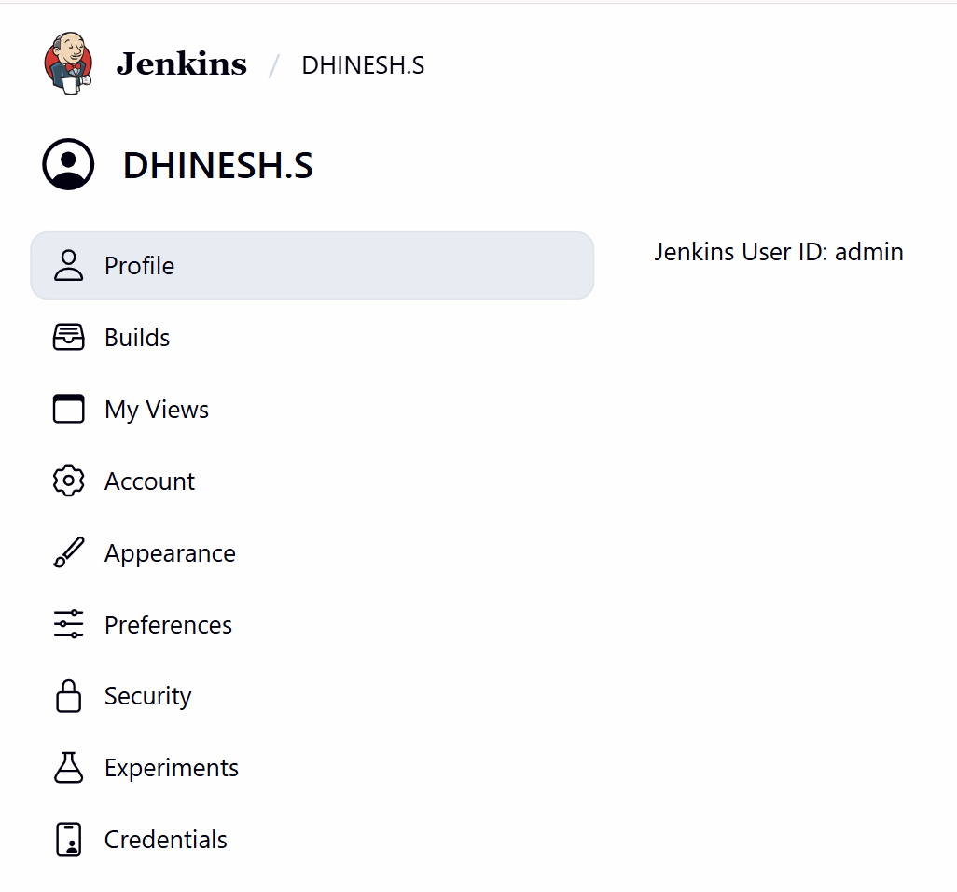
Install Jenkins (Windows / Linux)

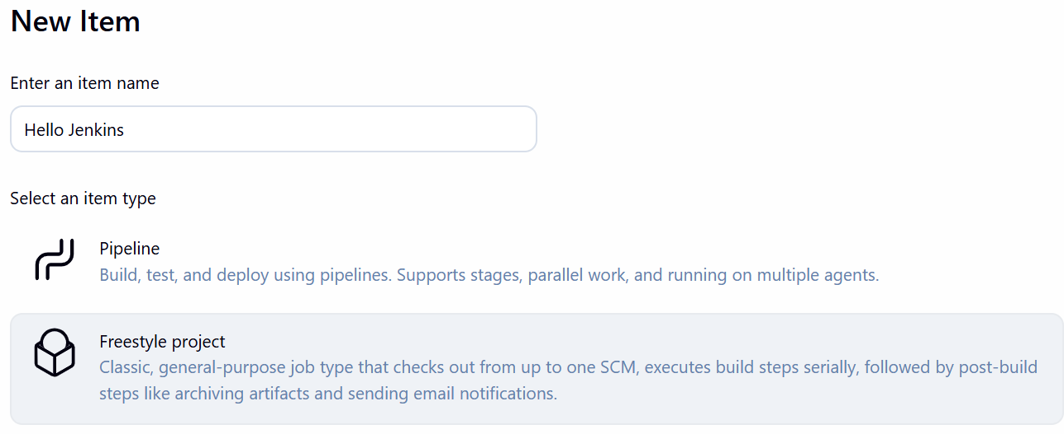

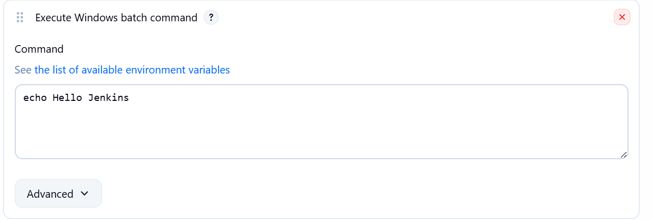

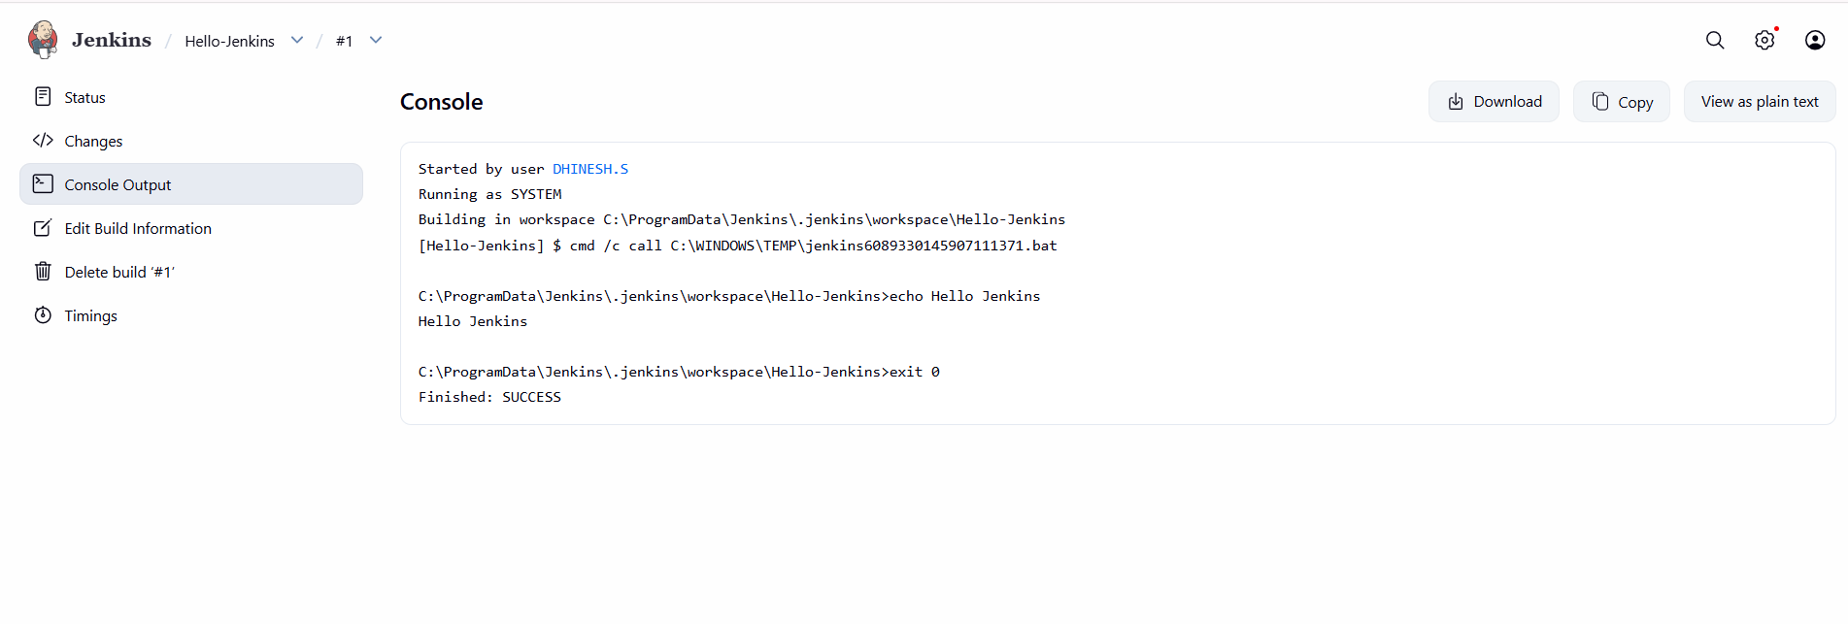Console Output showing “Hello Jenkins – SUCCESS”
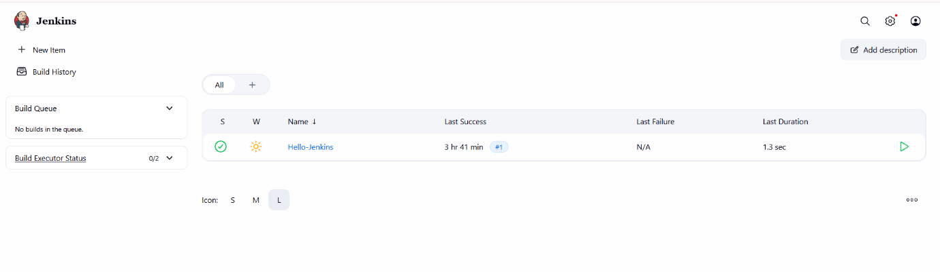
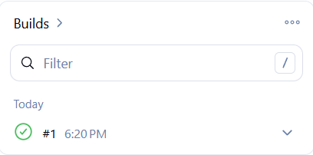

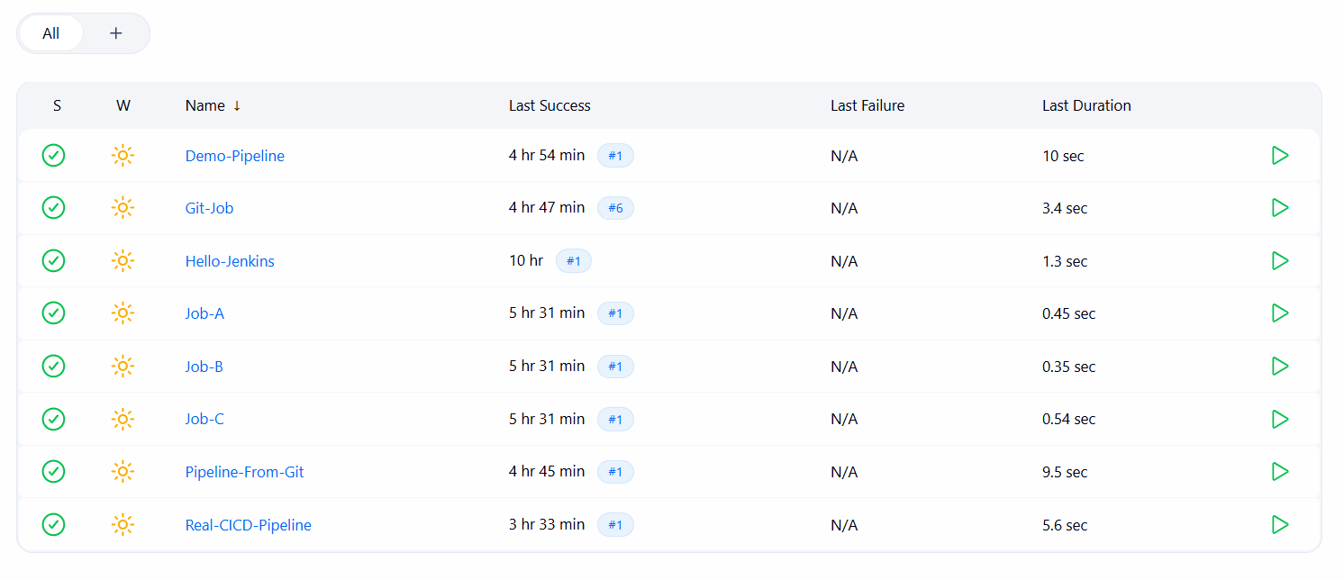
Jenkins Dashboard / Build History showing Hello-Jenkins

LAB 2 – Jenkins with GitHub
Aim
To integrate Jenkins with GitHub and automate builds on code changes.
Procedure
- Git was installed on the system.
- A GitHub repository named jenkins-lab was created.
- A Freestyle job named Git-Job was created in Jenkins.
- GitHub repository URL was configured under Source Code Management.
- A Windows batch command was added as build step.
- Poll SCM was enabled to trigger builds automatically.
- Code changes in GitHub triggered Jenkins builds automatically.
Output
Jenkins successfully pulled source code from GitHub and executed the build.
Result
Jenkins was successfully integrated with GitHub.

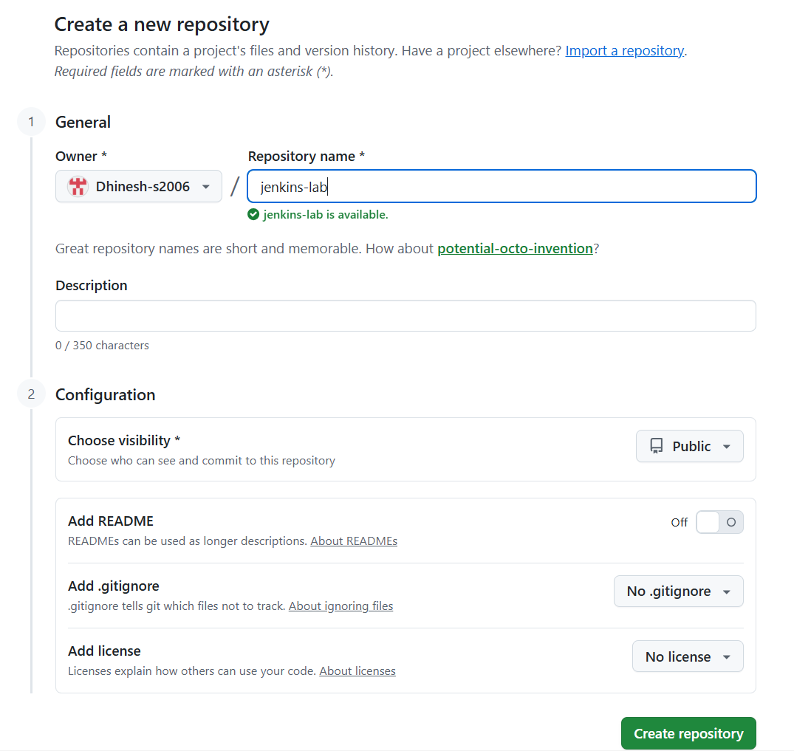
GitHub repository creation page (jenkins-lab)
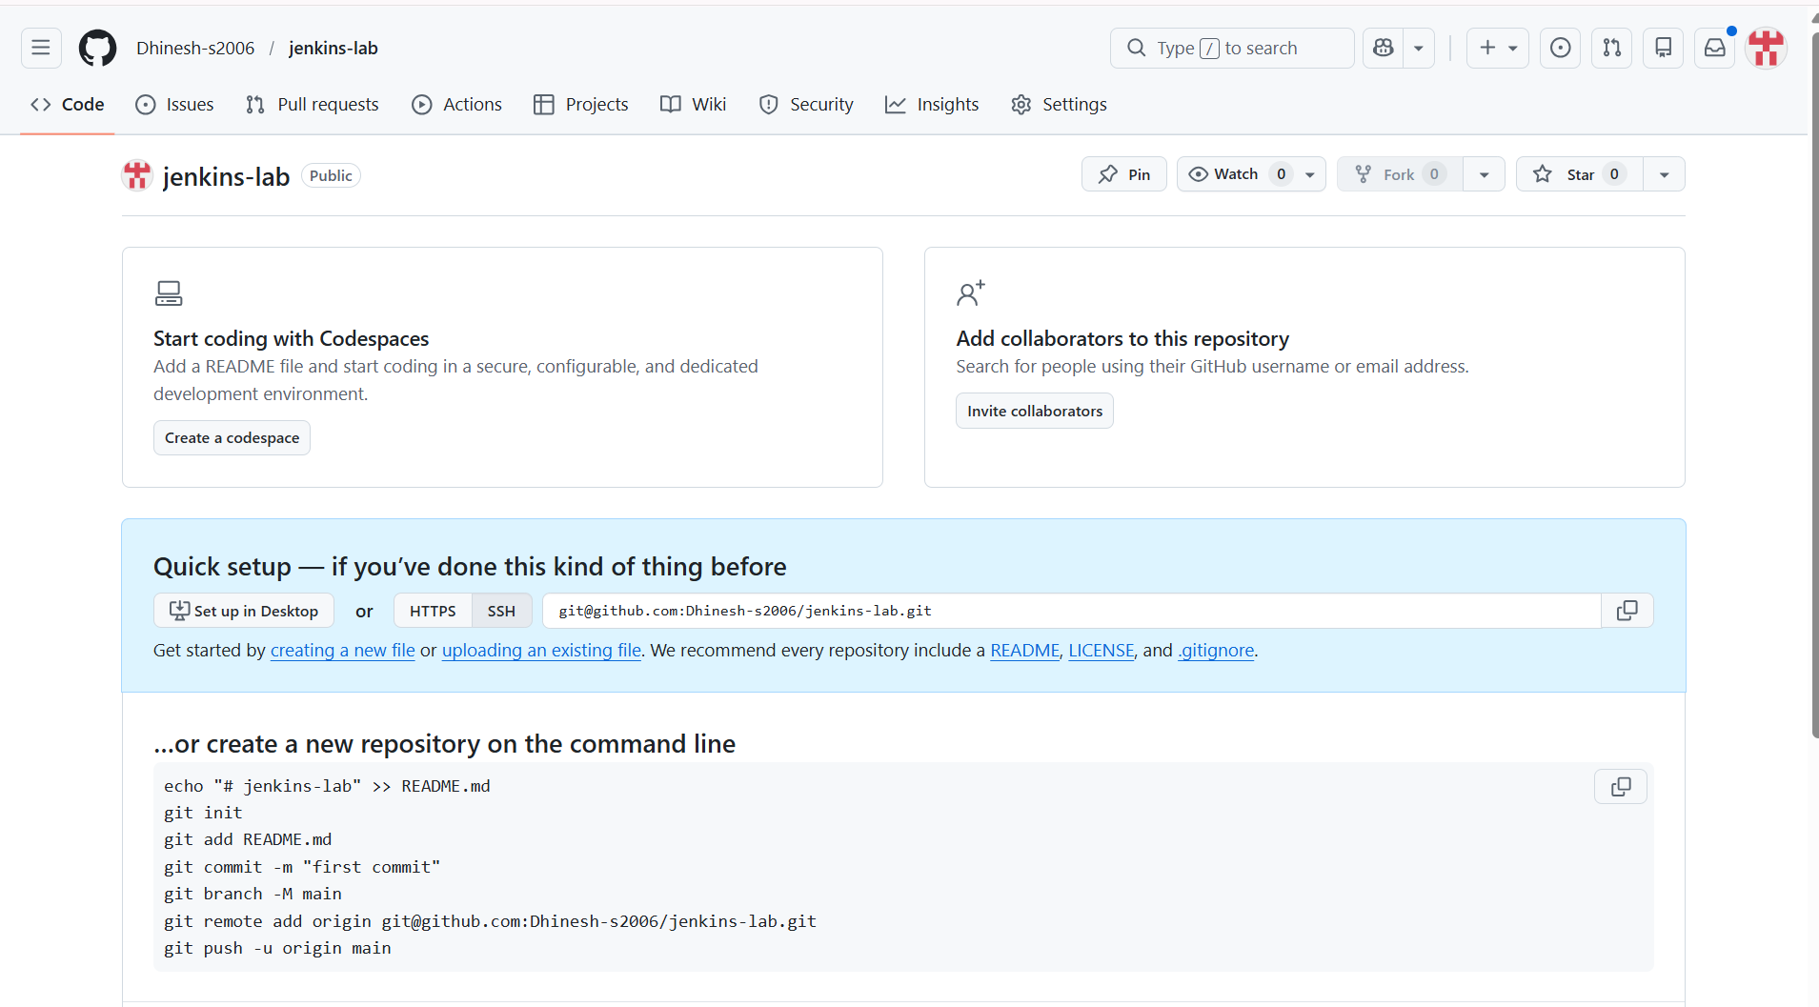
Jenkins Git configuration (Repository URL + Branch)

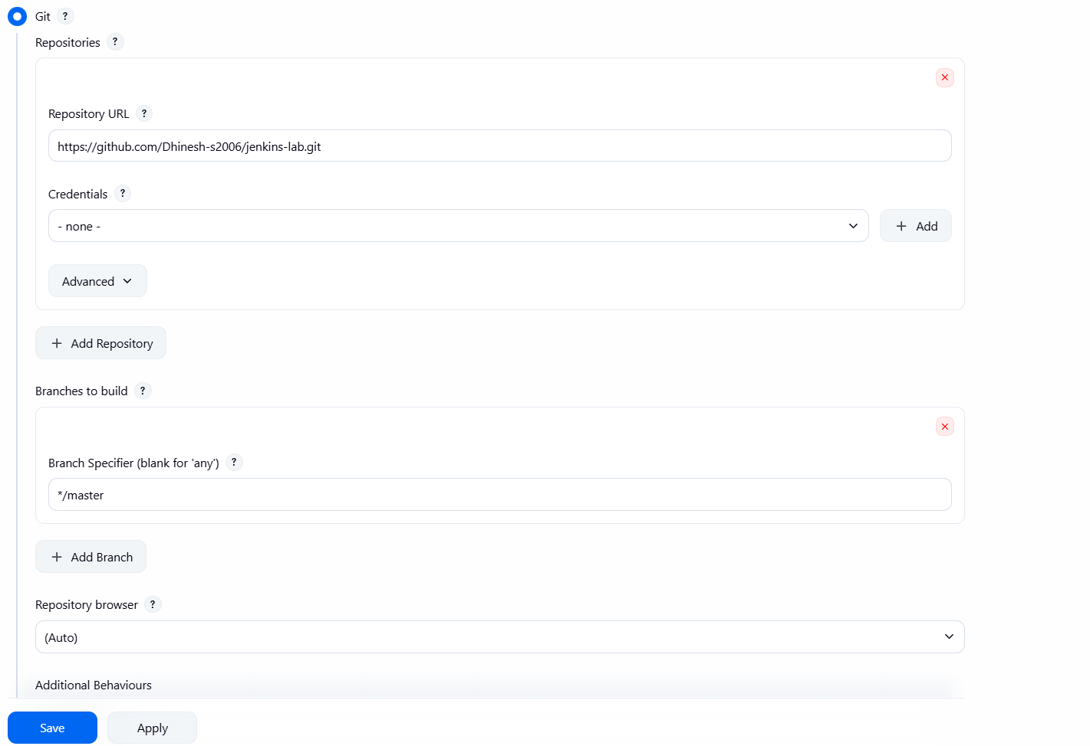
Configure Git in Jenkins

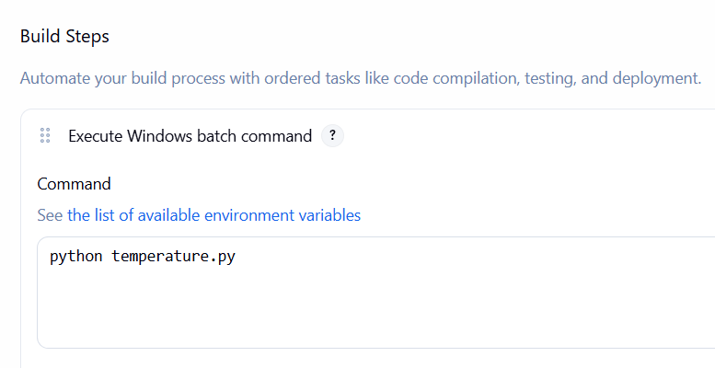
Build Setup
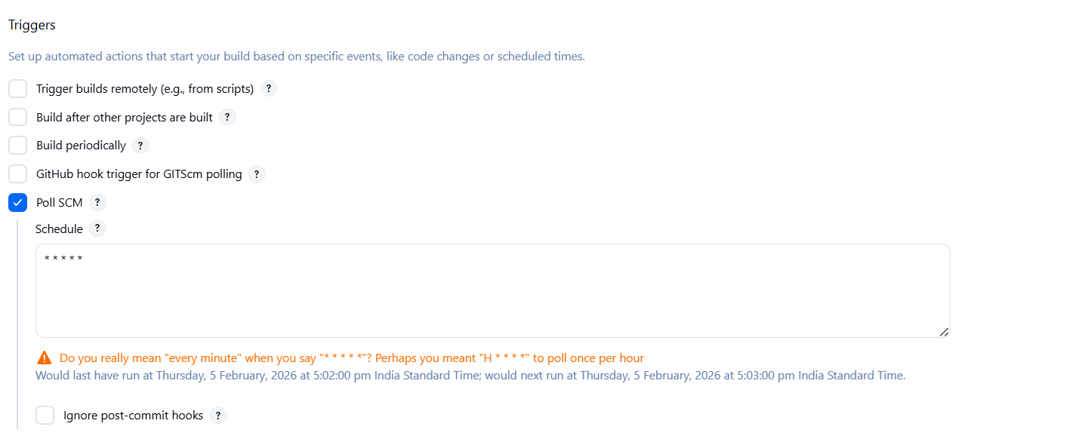
Poll SCM enabled (* * * * *)
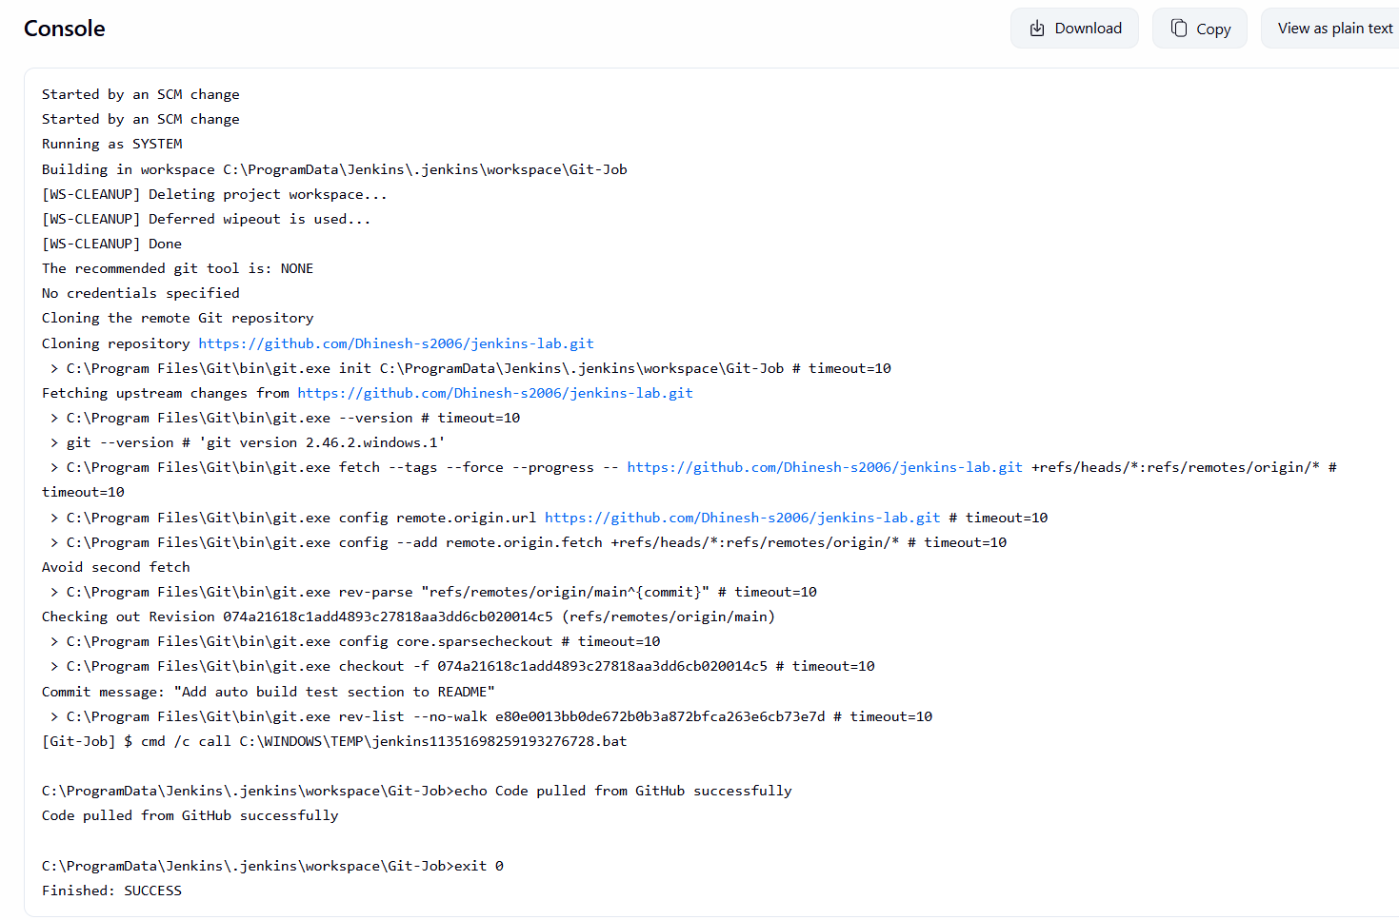
Git-Job Console Output showing SUCCESS
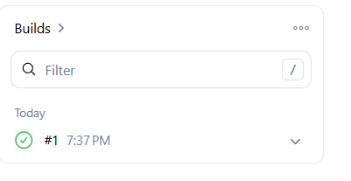
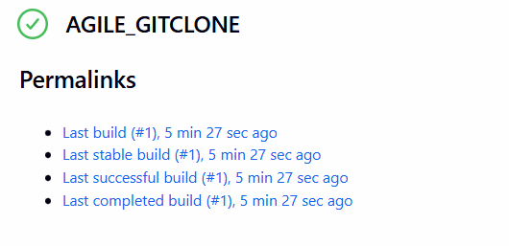
Build automatically on code change

LAB 3 – Job Chaining (Visual Flow)
Aim
To understand CI job flow using job chaining in Jenkins.
Procedure
- Three Freestyle jobs were created:
  - Job-A (Build)
  - Job-B (Test)
  - Job-C (Deploy)
- Job-A was configured to trigger Job-B using post-build actions.
- Job-B was configured to trigger Job-C.
- Job-A was executed manually.
- Job-B and Job-C were triggered automatically.
Output
All jobs executed sequentially in Build → Test → Deploy order.
Result
Job chaining was successfully implemented in Jenkins.

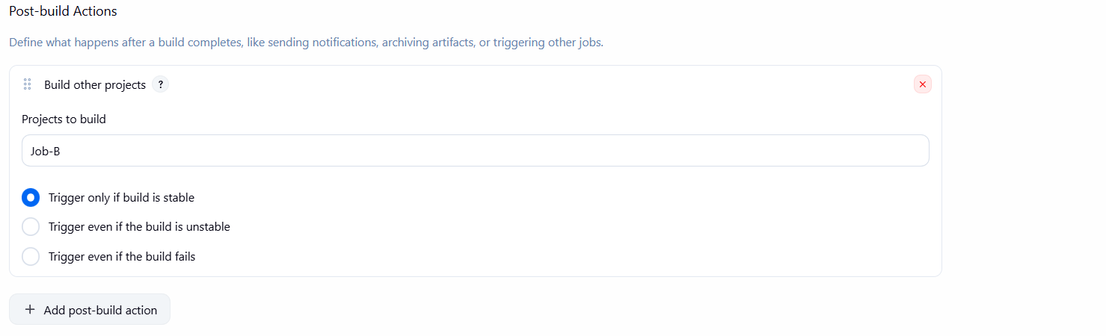
Post-build action: Job-A triggering Job-B
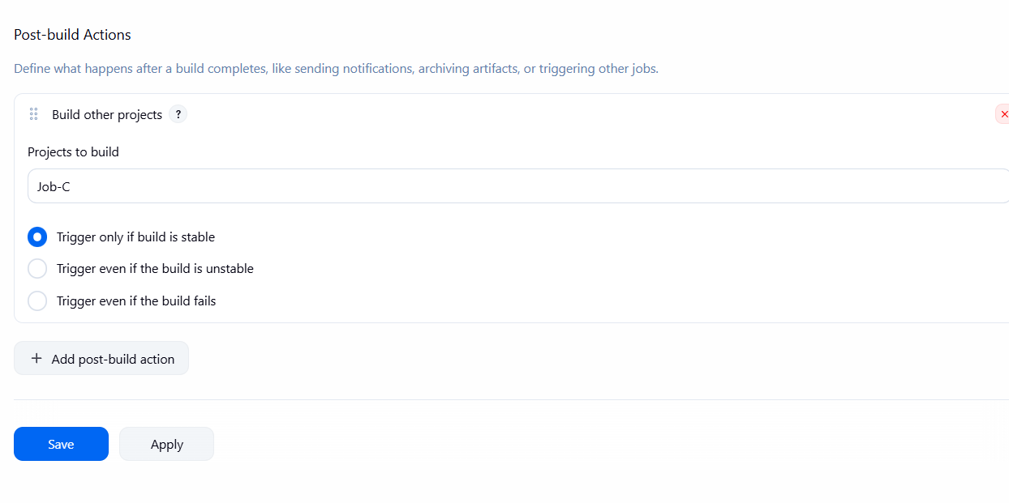
Post-build action in Job-B → Trigger Job-C
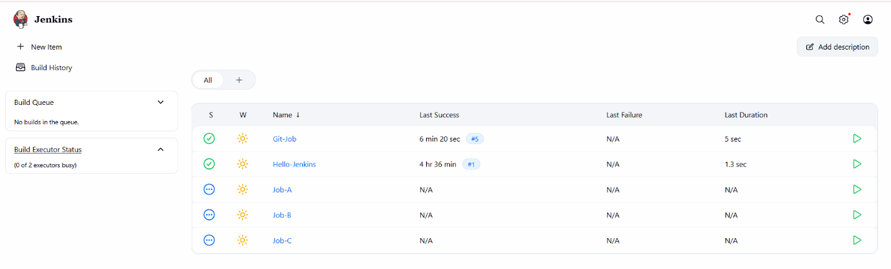

Build history showing Job-A → Job-B → Job-C

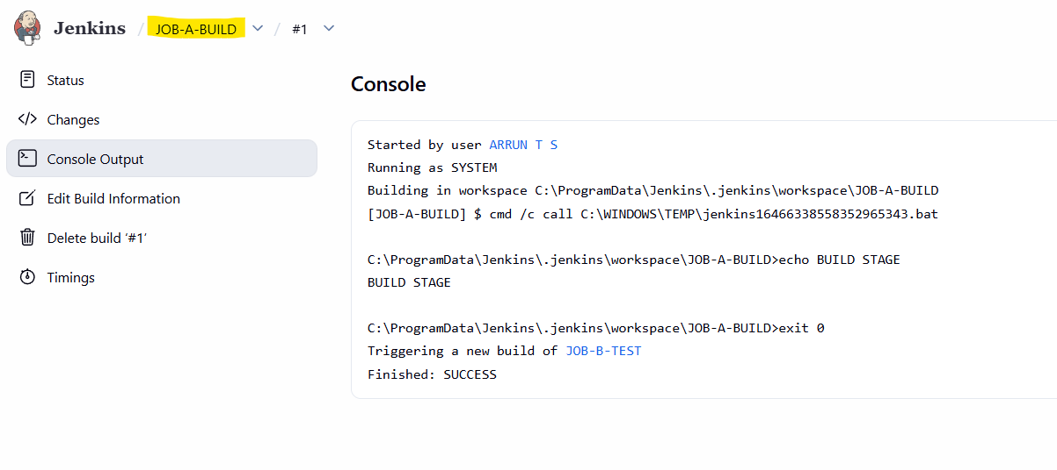
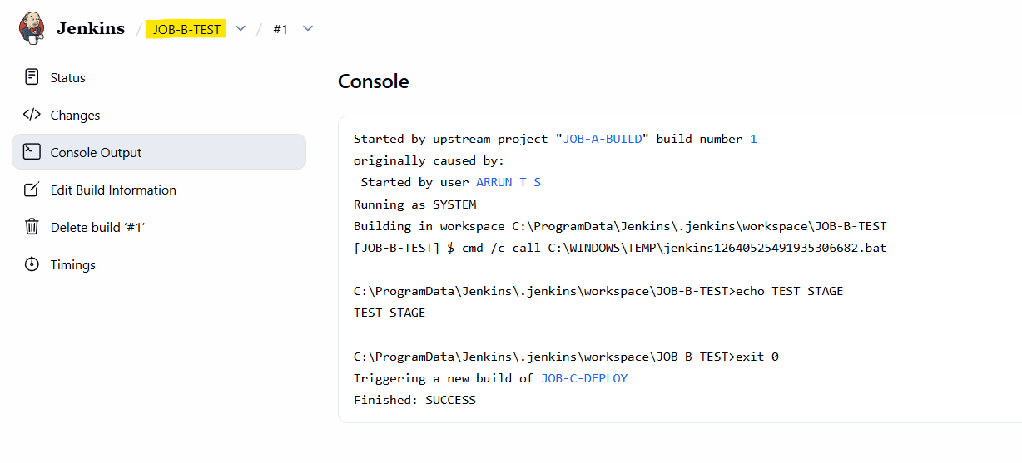
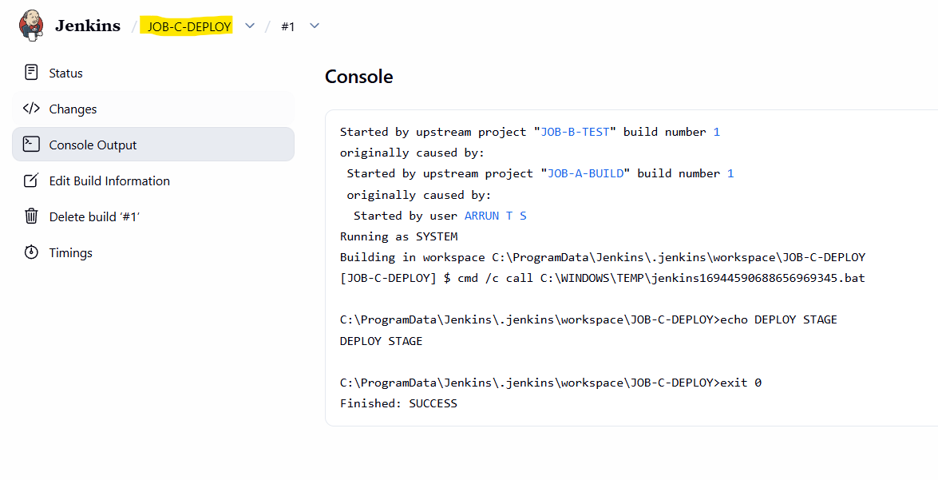
View job chaining visually
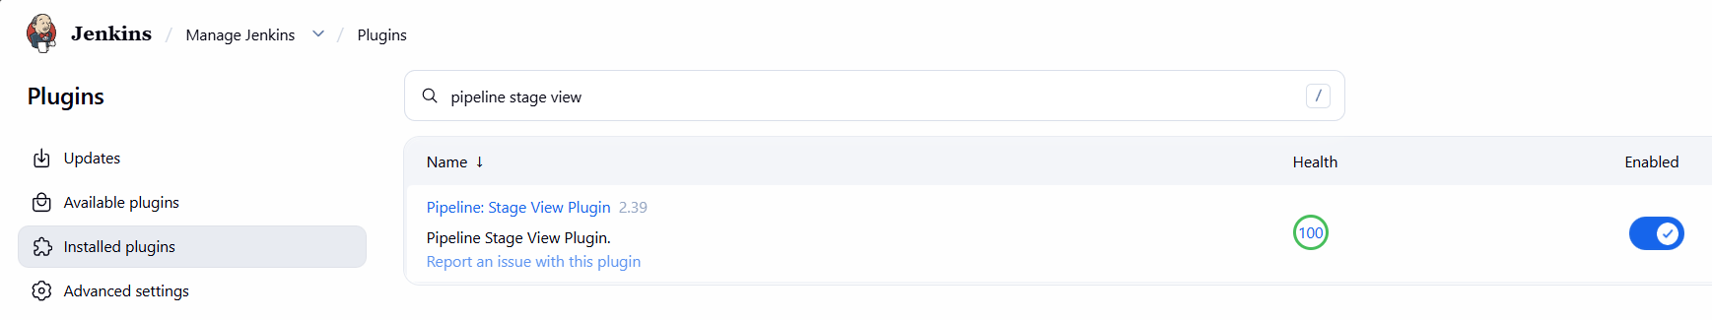
Install Pipeline Stage View

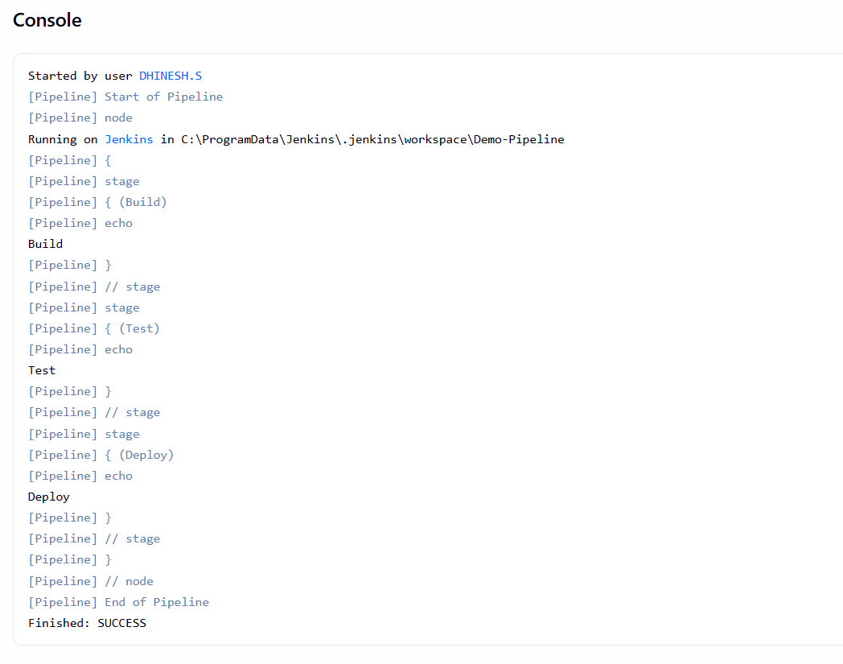
Console Output

LAB 4 – Jenkins Pipeline
Aim
To create and execute a Jenkins declarative pipeline.
Description
A Jenkins Pipeline is a code-based way to define CI/CD stages.
Procedure
- A Pipeline job named Demo-Pipeline was created.
- Declarative pipeline code was written in Jenkins UI.
- Build, Test, and Deploy stages were defined.
- The pipeline was executed.
Output
All pipeline stages executed successfully.
Result
Jenkins pipeline was created and executed successfully.

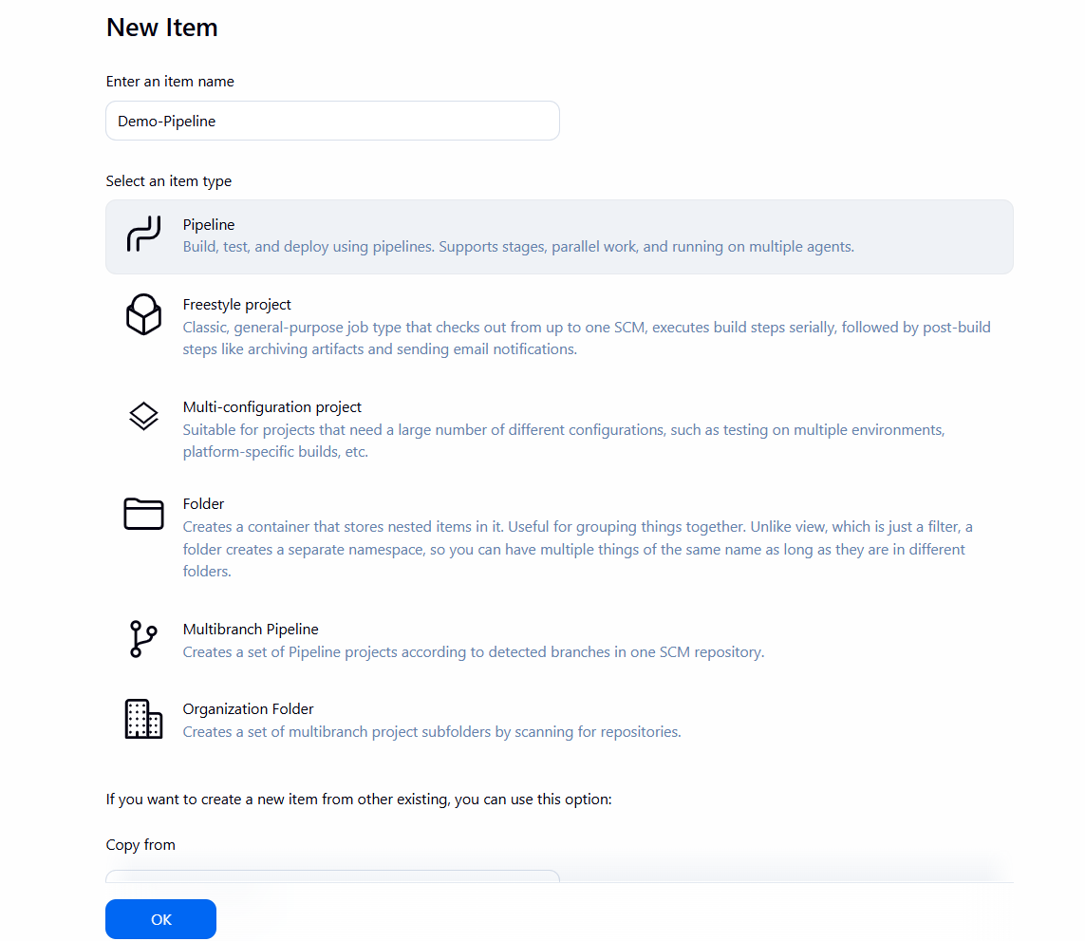

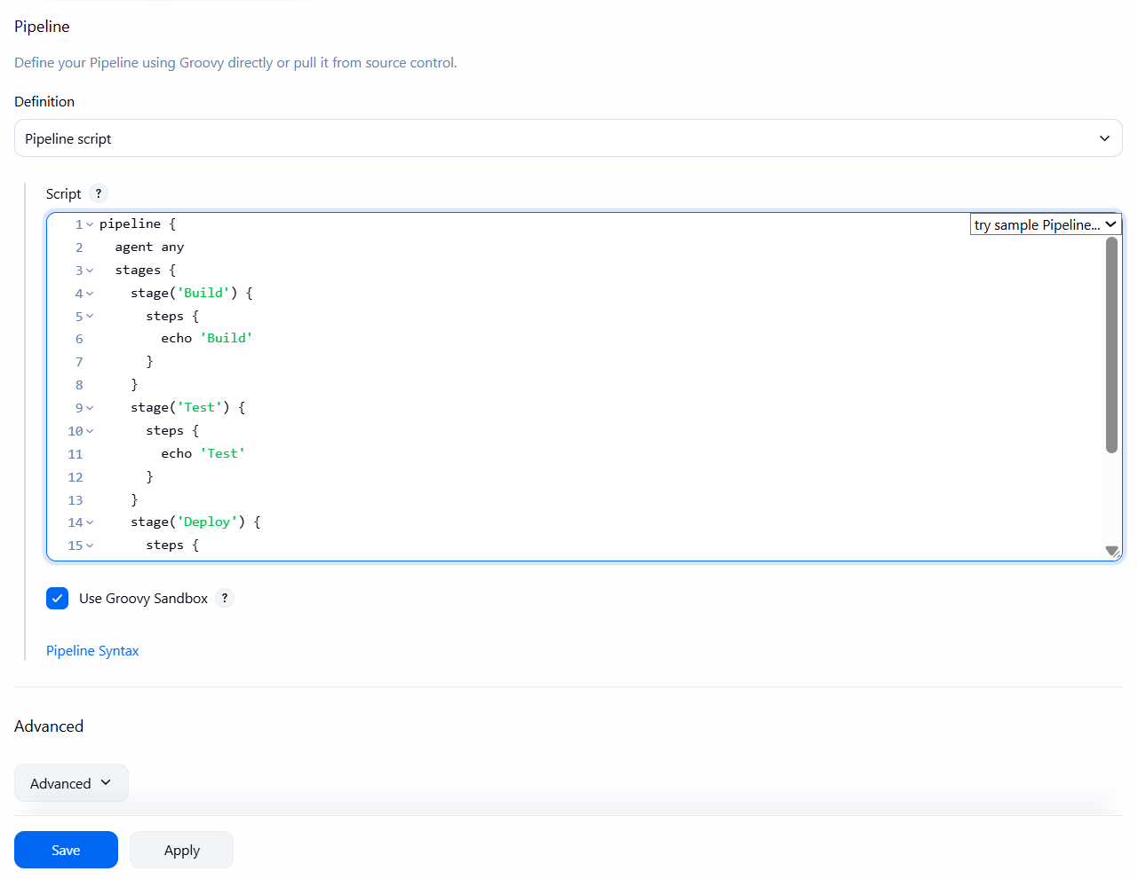
Configuration Changes

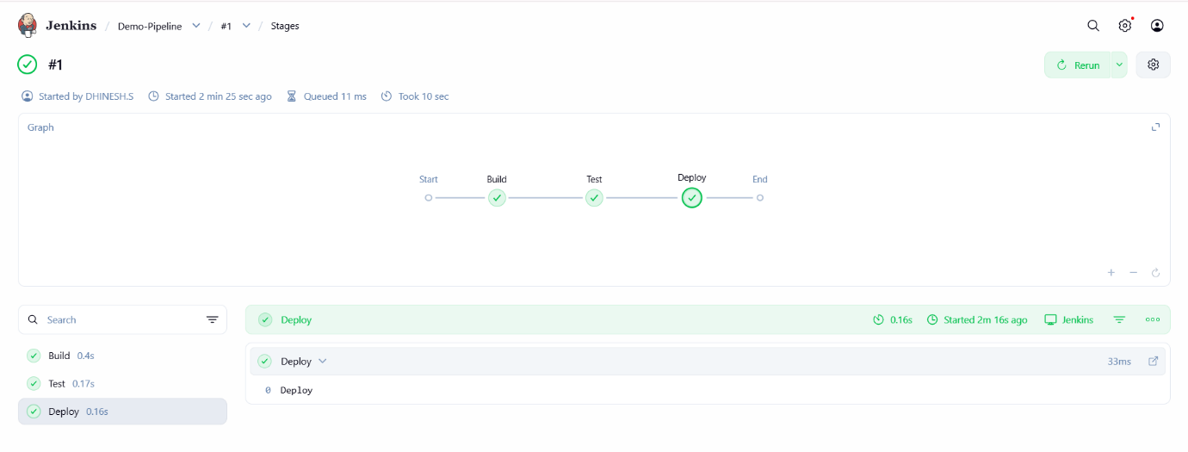

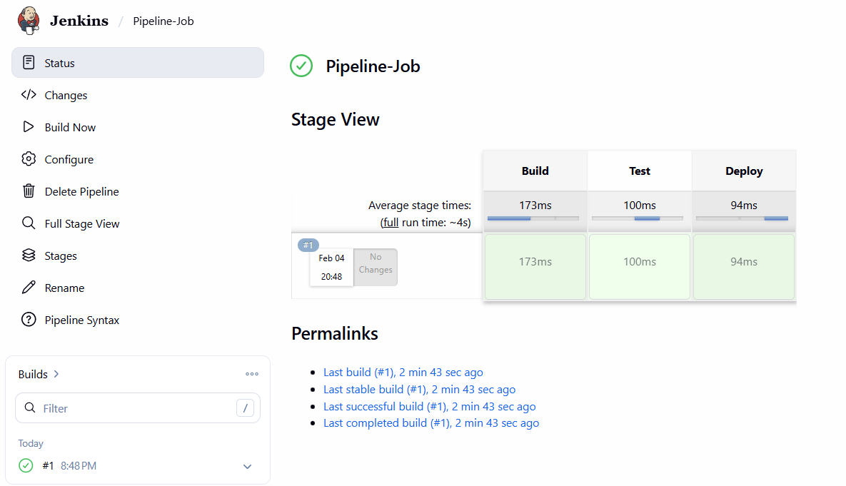

LAB 5 – Pipeline as Code (Jenkinsfile)
Aim
To implement Pipeline as Code using Jenkinsfile.
Procedure
- Jenkinsfile was created in GitHub repository.
- Pipeline job was configured to fetch Jenkinsfile from GitHub.
- Jenkins automatically executed pipeline stages.
- Stage-wise execution was observed.
Pipeline Script
pipeline {
agent any
stages {
stage('Build') {
steps {
echo 'Build'
}
}
stage('Test') {
steps {
echo 'Test'
}
}
stage('Deploy') {
steps {
echo 'Deploy'
}
}
}
}
Output
Pipeline executed successfully using Jenkinsfile.
Result
Pipeline as Code was successfully implemented.

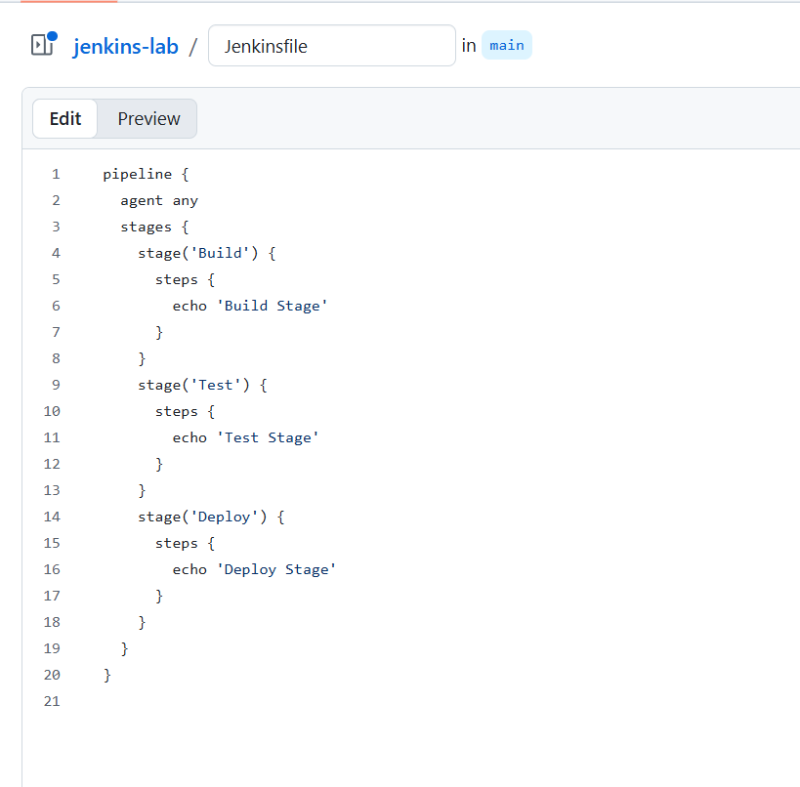
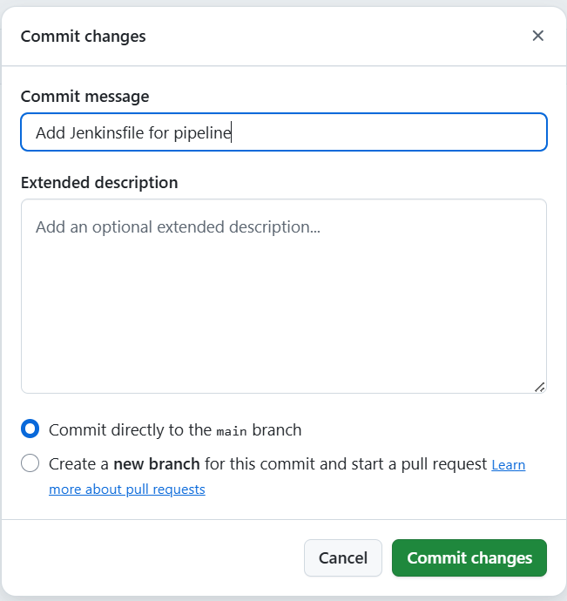

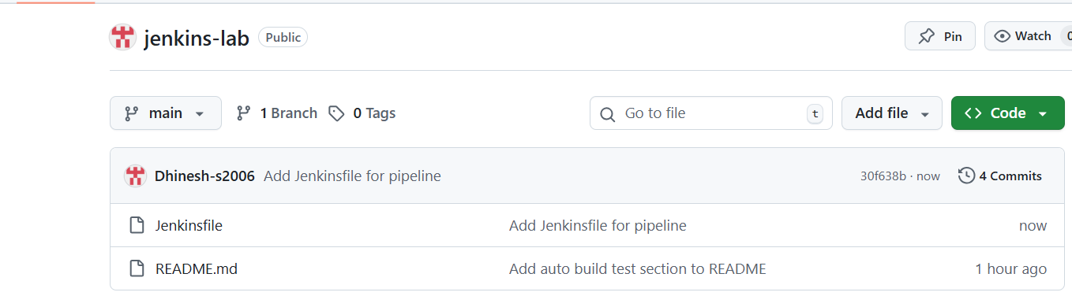
Changes Made In Repository(GitHub Jenkinsfile )
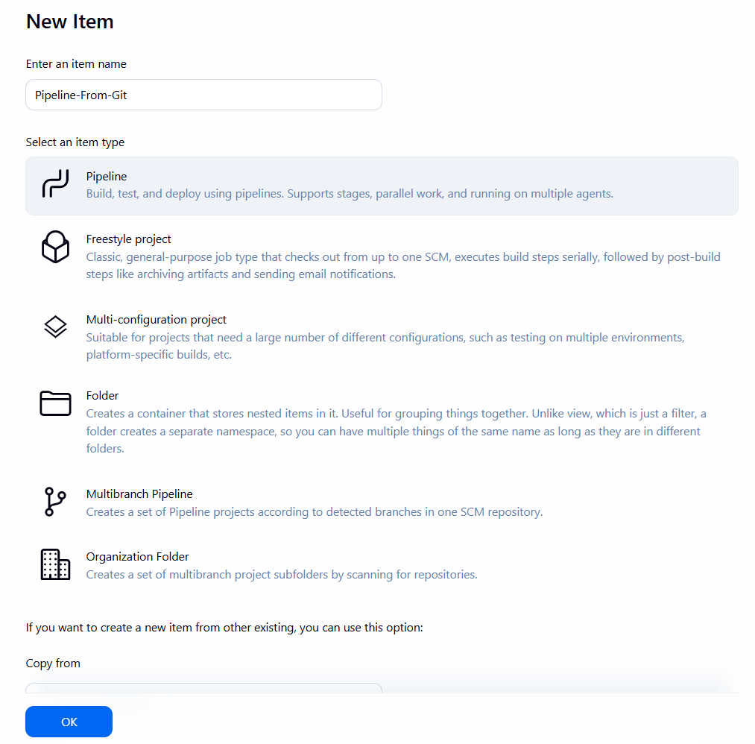
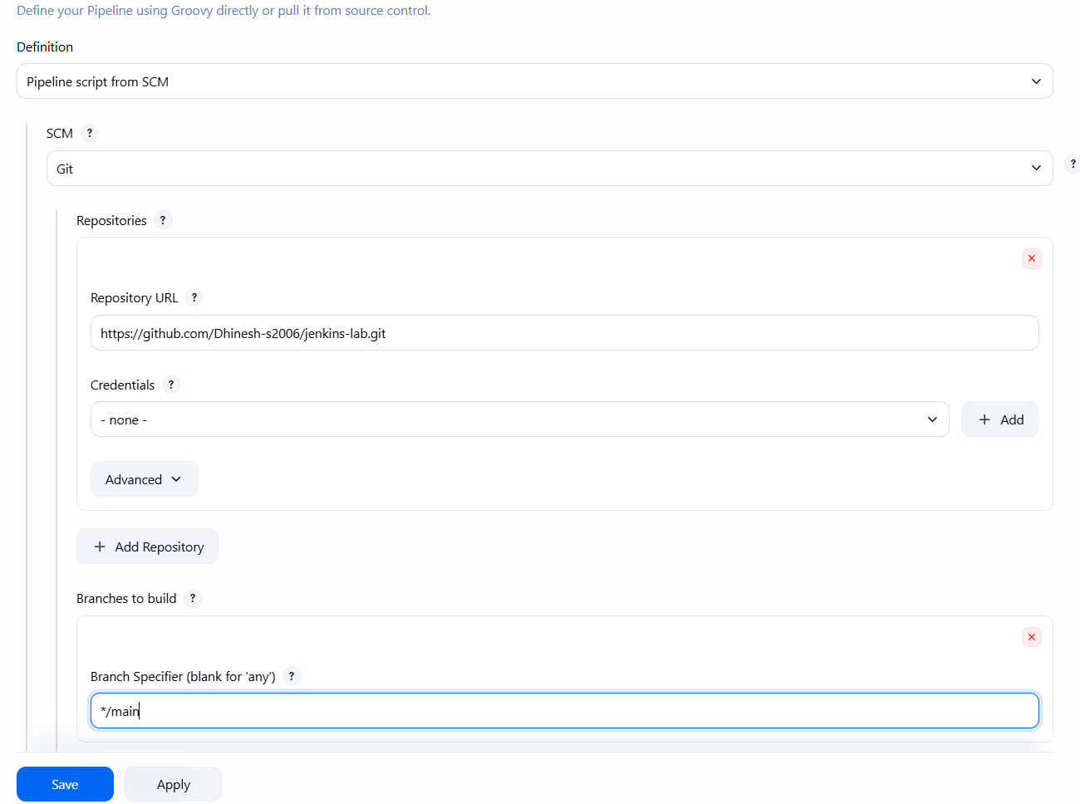
Configuration Changes
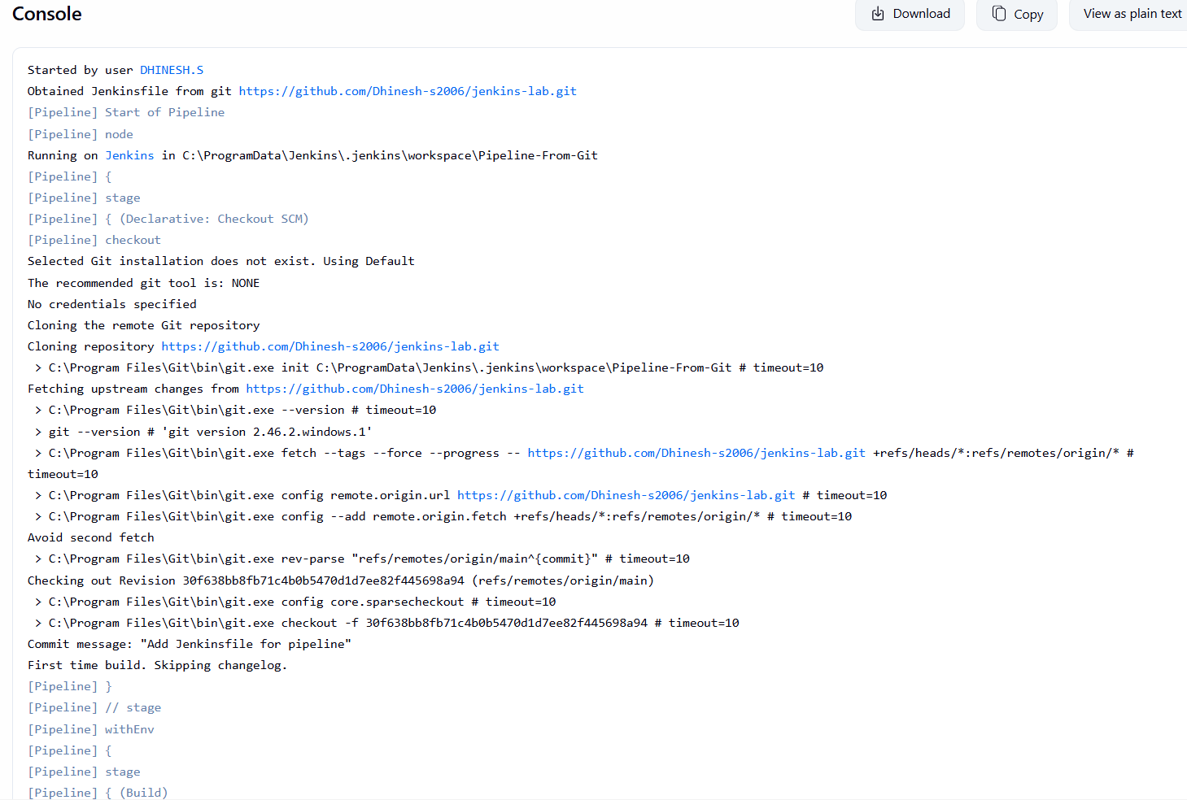
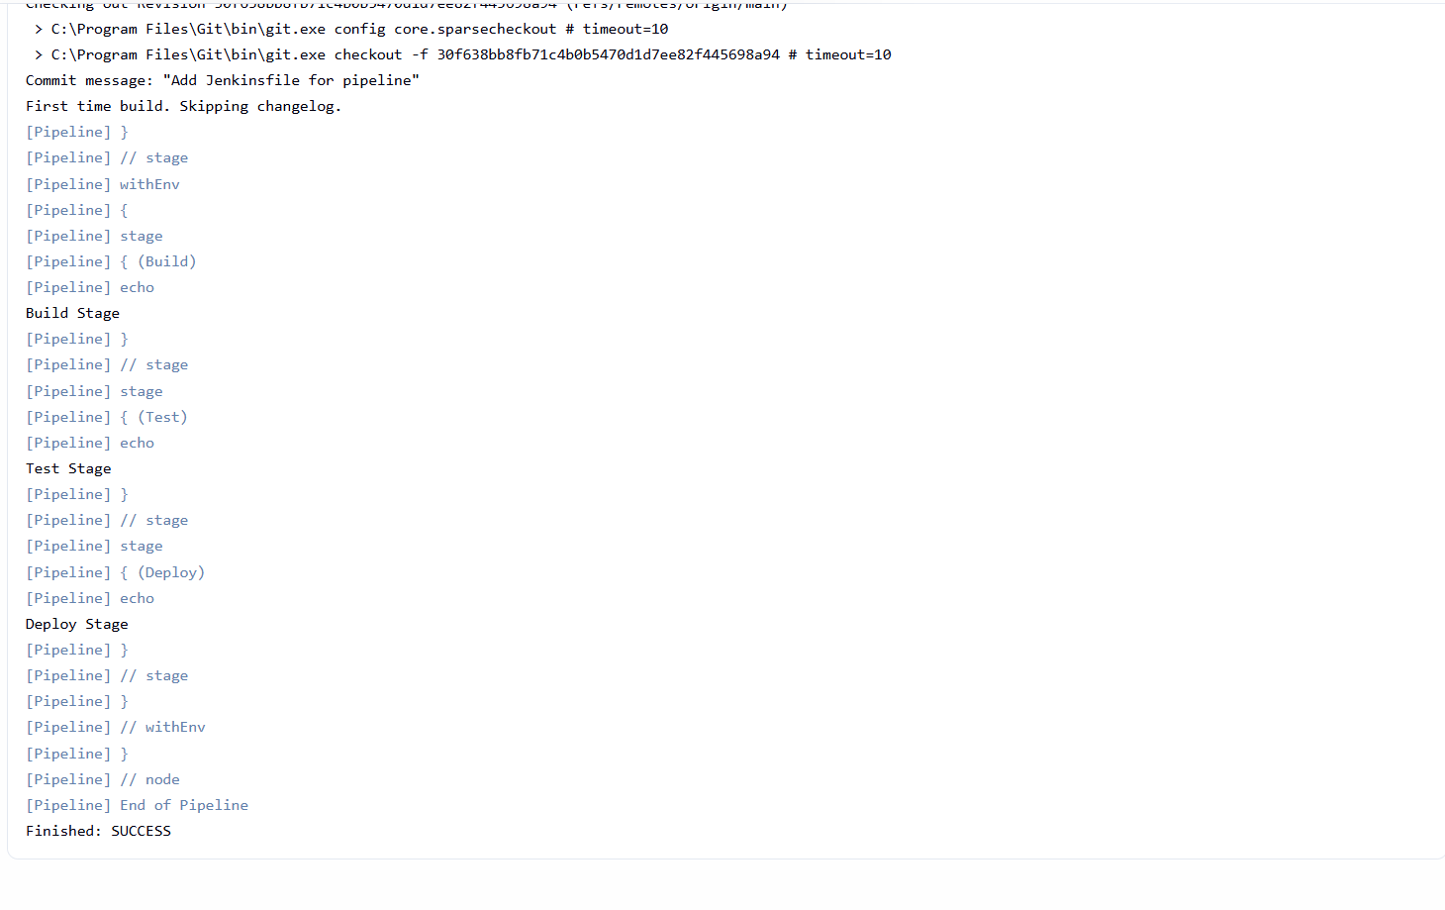

Console Output(Jenkins pipeline execution)

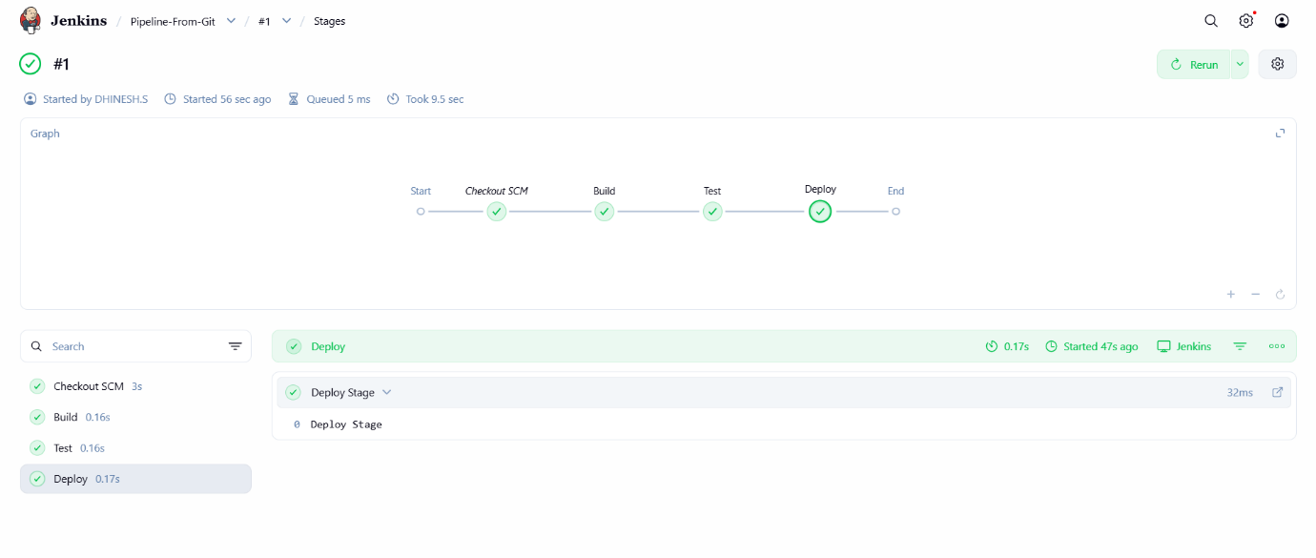
Pipeline stage view (Build → Test → Deploy)
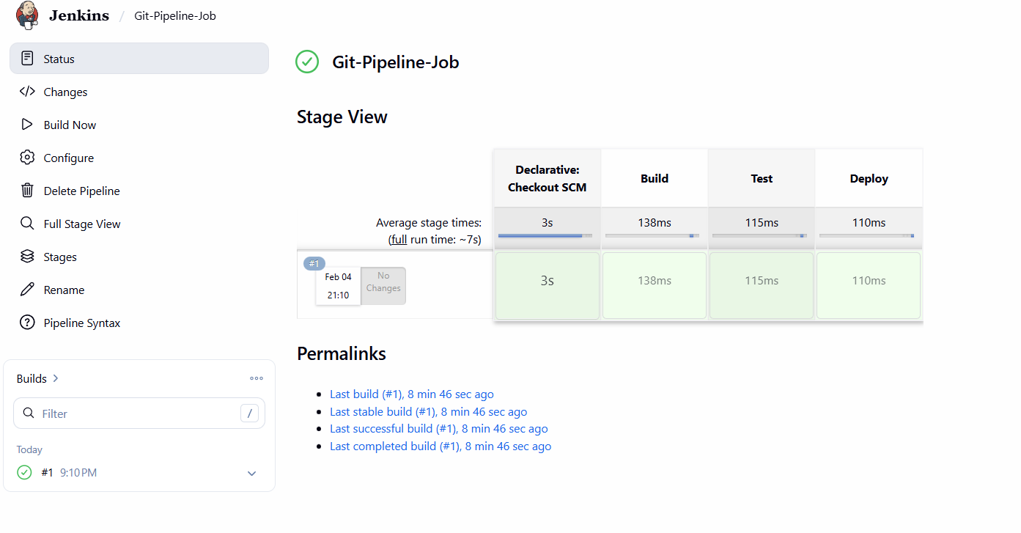

Modify Jenkinsfile and rebuild

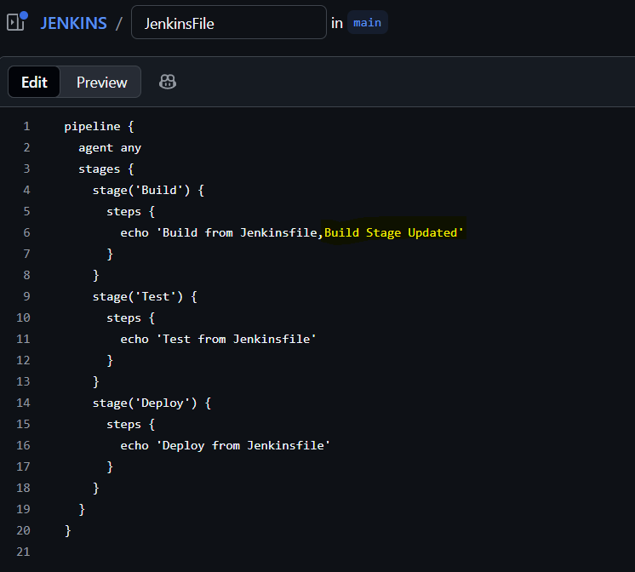

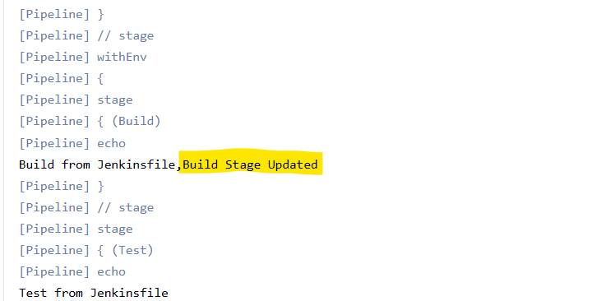
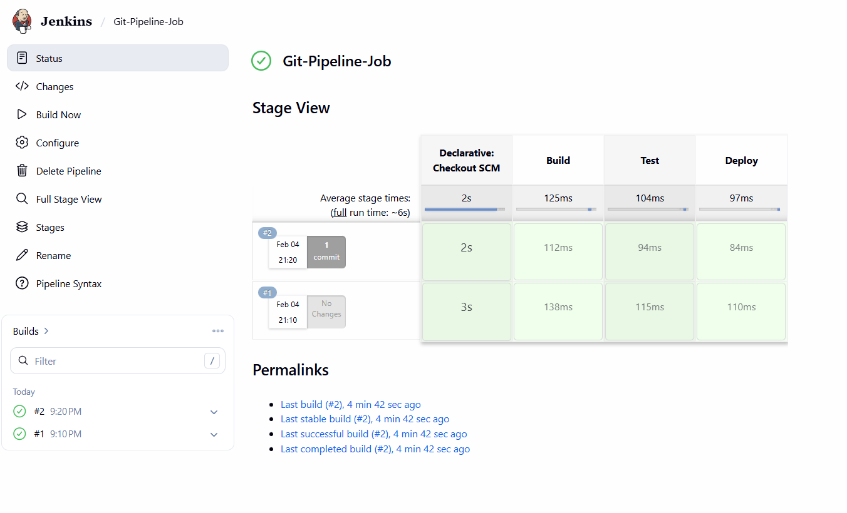
View Stage View

LAB-6 : Build Real CI/CD Pipelines

Aim
To design, build, and execute a production-grade CI/CD pipeline in Jenkins including build, test, code quality, deployment, and notification stages.
Description
Continuous Integration and Continuous Deployment (CI/CD) is a process that automates building, testing, and deploying applications. Jenkins pipelines help in defining these steps as code and executing them automatically.
Procedure
- Jenkins dashboard was opened.
- A new Pipeline job named Real-CICD-Pipeline was created.
- A declarative pipeline script was written including the following stages:
  - Build
  - Unit Test
  - Code Quality
  - Deploy
- Environment variables were defined inside the pipeline.
- Post-build actions were added to handle success and failure cases.
- The pipeline was saved and executed using Build Now.
- Console output and stage-wise execution were verified.

Pipeline Script
pipeline {
agent any

environment {
APP_NAME = "DemoApp"
ENV = "Production"
}

stages {

stage('Build') {
steps {
echo "Building application using Maven/Node (simulated)"
echo "Application Name: ${APP_NAME}"
}
}

stage('Unit Test') {
steps {
echo "Running unit tests (simulated)"
echo "All tests passed"
}
}

stage('Code Quality') {
steps {
echo "Running SonarQube code quality analysis (simulated)"
echo "Code quality check passed"
}
}

stage('Deploy') {
steps {
echo "Deploying ${APP_NAME} to ${ENV} server (simulated)"
echo "Deployment successful"
}
}
}

post {
success {
echo "Pipeline executed successfully"
echo "Sending success notification (Email/Slack simulated)"
}
failure {
echo "Pipeline failed"
echo "Sending failure notification (Email/Slack simulated)"
}
}
}

Output
- Build, Test, Code Quality, and Deploy stages executed successfully.
- Pipeline completed with SUCCESS status.
- Notifications were triggered after successful execution.

Result
A production-grade CI/CD pipeline was successfully built and executed using Jenkins.

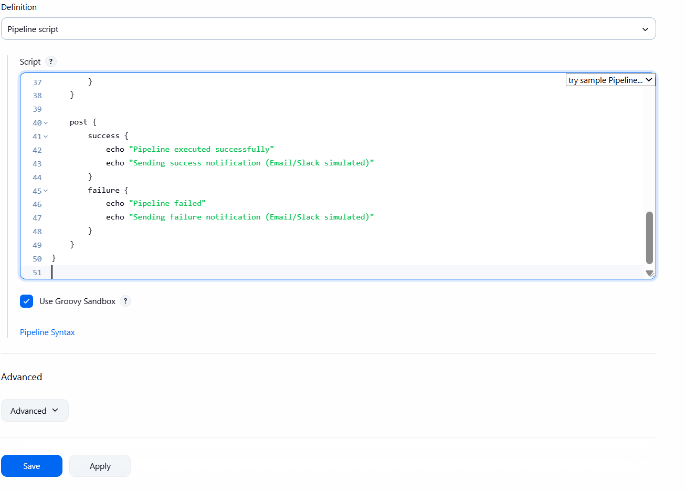
Configuration Changes

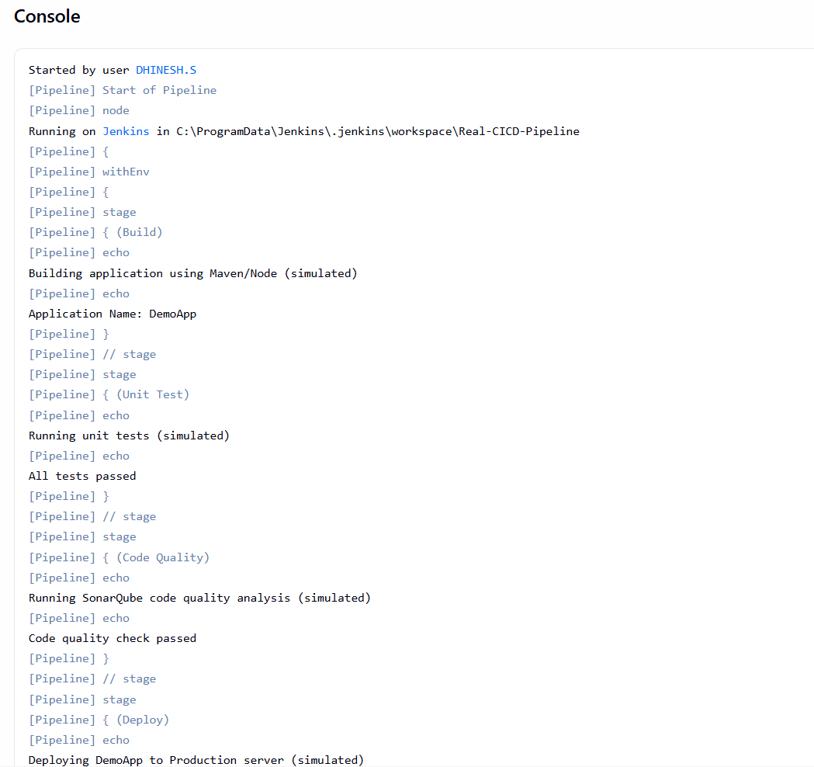

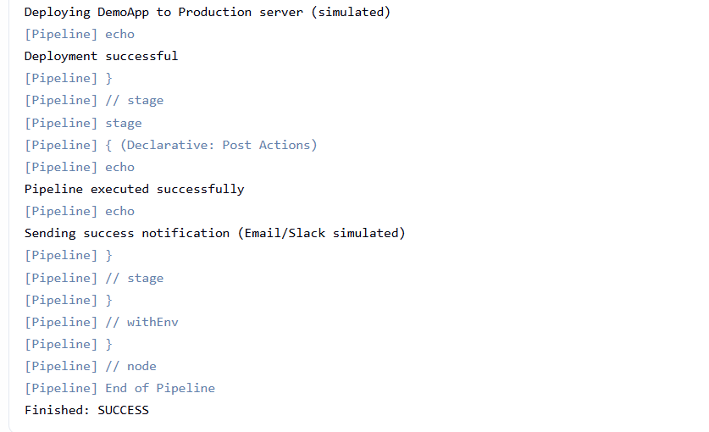
Console Output showing pipeline executed successfully

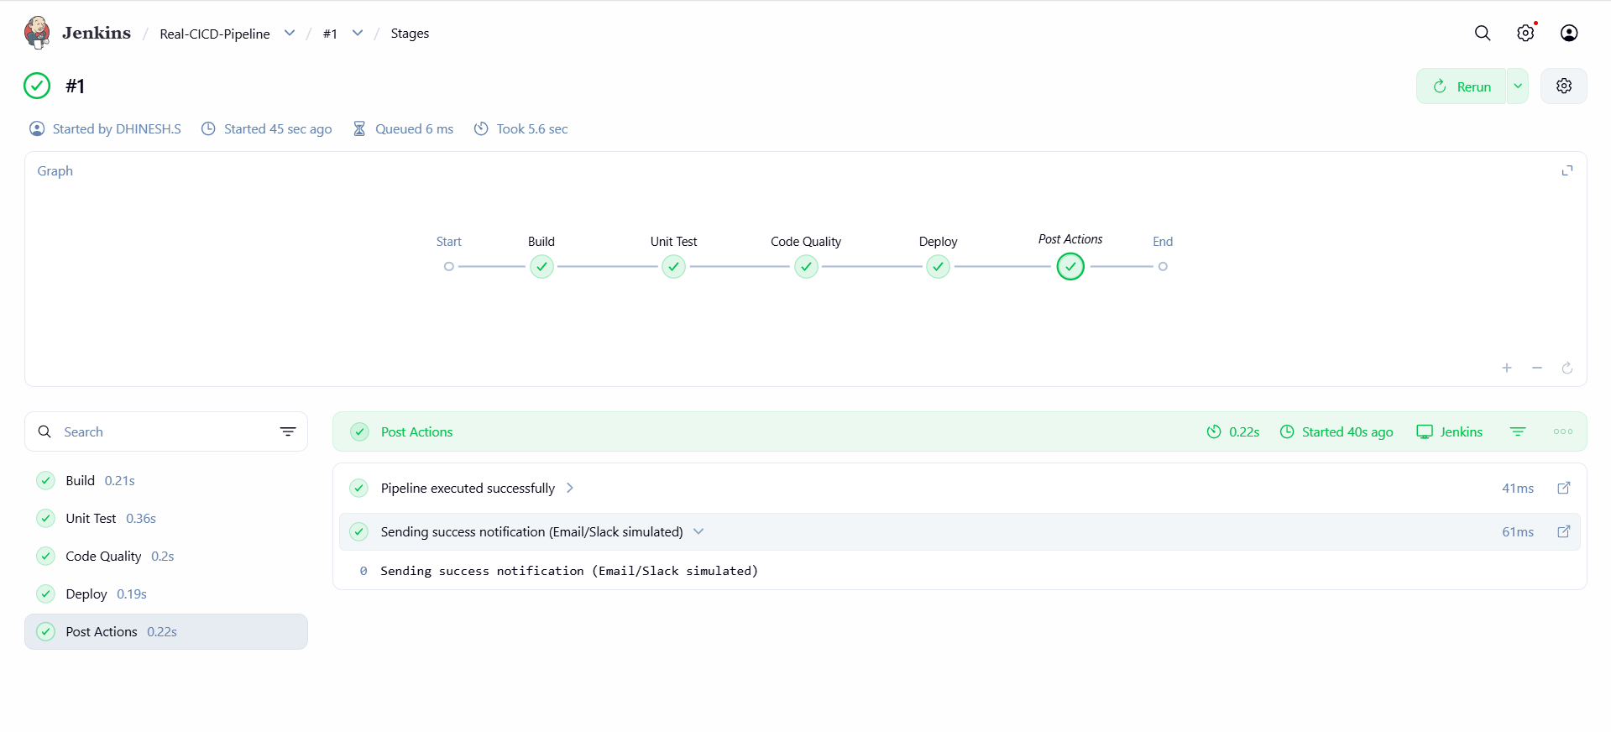Pipeline Stage View showing successful execution of all stages

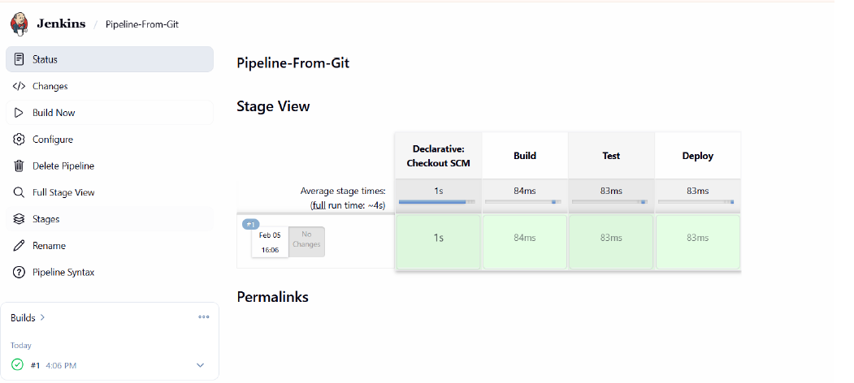
Trigger Build Automatically

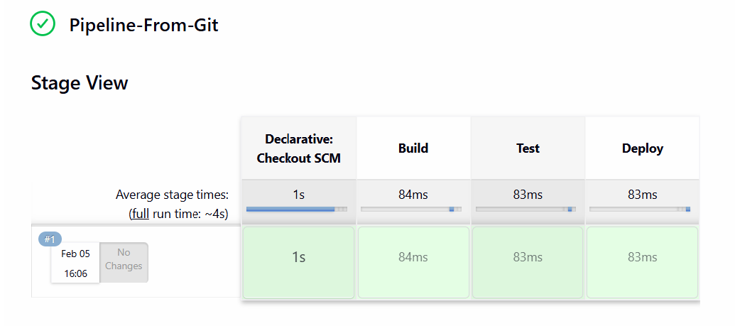
View Stage View
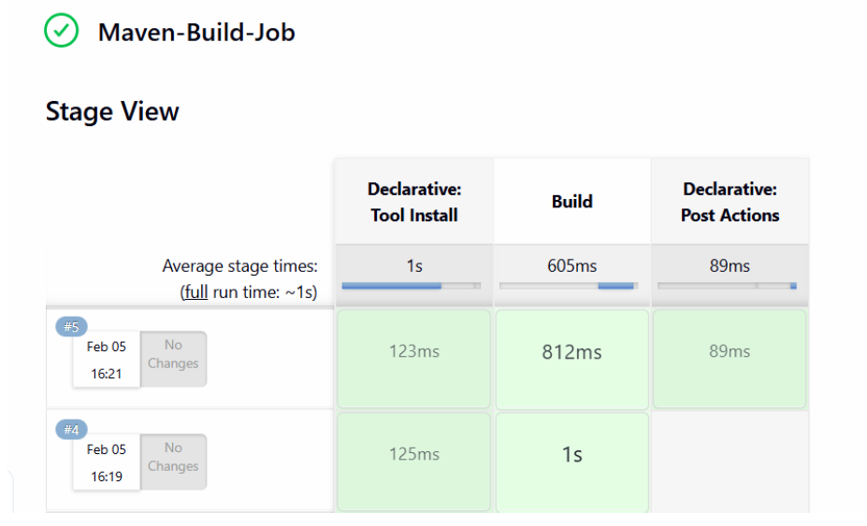
LAB 7 – Jenkins Administration (CONCEPT)
Aim
To study and perform Jenkins administration tasks such as user management, node configuration, plugin management, security, backup, and upgrade process.
Description
Jenkins infrastructure management involves configuring users, managing build agents, installing plugins, securing the system, maintaining backups, and upgrading Jenkins for stability and performance.

Procedure
- Jenkins dashboard was opened and administrative options were accessed.
- User management was verified by viewing configured users.
- Node configuration was checked using the built-in Jenkins node.
- Installed plugins were verified using Plugin Manager.
- Jenkins home directory was identified for backup and restore purposes.
- Security configuration options were reviewed.
- Jenkins version details were checked to understand the upgrade process.

Output
- Jenkins users and nodes were successfully verified.
- Plugin management and security options were observed.
- Jenkins system configuration and version details were displayed.

Result
Jenkins infrastructure and administration tasks were successfully studied and verified.
